**Quiet Corners: An application for a peaceful place**

Steven Bewerse, Michael Ware, and Erik Hendrickson, University of South Florida

Table of Contents:

|  |  |
| --- | --- |
| Cover Page | 1 |
| Table Of Contents | 2 |
| A. Introduction | 3 |
| B. Vision and Scope  I. Opportunity | 3  3 |
| II. Vision Statement | 3 |
| III. Major Features | 3 |
| IV. Assumptions And Dependencies | 3 |
| V. Scope Of Initial Release | 3 |
| VI. Scope Of Potential Future Releases | 4 |
| VII. Operating Environment | 4 |
| VIII. Competitive Analysis | 4 |
| C. Dialogue Map | 5 |
| D. Screen Mockups | 6 |
| E. Features List | 9 |
| F. Conclusion | 11 |
| G. References | 11 |

1. Introduction:

The goal of this application is to create a program which logs local spaces which users find beneficial to studying and record them so that others may utilize them. This app will use a variety of built in phone sensors to record measurements of the surrounding environment, and store them on an external database so that others may find them. Furthermore, the goal is an intuitive program that can either use local advertising of places as ad revenue or the use of exclusive member’s only features. This will be outlined in the following sections.

1. Vision and Scope
2. Opportunity:

Quiet Corners is a humanitarian app, meant to help students looking for nearby quiet places to get away and study. Monetization is possible with either local ads or premium but features, but this will most likely not be included in the initial release since there will be a small user base.

1. Vision Statement:

Long term, this app may possibly be an invaluable tool for users not only at the University of South Florida but other schools, city parks, libraries, and any number of locations. Users could rate spots on how useful they thought it was to study, form and reserve spots for groups to study, the possibilities are broad. A minor feature could be awards or badges for the “explorers,” those that find and record highly rated spots. This app has a large platform which could be utilized and implemented.

1. Major Features:

The app will be expected to use the audio sensor, GPS sensor, and the internal network tracking. These will be used to record sound, location, and Wi-Fi strength respectively. Once recorded, the user would submit this information to an external database which would contain entries for all other spots for users to search for based on their current location. This database will most likely be in MySQL. The app, for its initial release, will be restricted to Android only but a web client, iOS app, or Windows phone app are not out of the realm of possibility.

1. Assumptions & Dependencies:

The app will be restricted to only the USF area initially. This is purely a scope limitation, there would be no issue with a world-wide release but the user base will be around the college area. This is to keep our initial user base in sharp focus. The next dependency is that a server will be set up to hold all saved locations. This will be provided by one of our members as a temporary initial solution.

1. Scope of Initial Release:

Initial release will be on the Play store open to anyone to download. However, we expect that the users of this program will be used exclusively by students and faculty at USF. All initial locations added will be anonymous, as the implementation and security of user data is out of scope in the allotted time. Users will be able to record a spot with sound, light, and network data/security, and view recorded locations on the map in the application. We will also allow the rating and reporting (for improper use or nonexistent locations) of recorded spots, but purely on an anonymous basis as a 1 to 5 star rating.

1. Scope of Potential Future Releases:

A user system and additional recorded location data will be top of the priority list for future versions. This could be hours that spots are available, picture data, comments, nearest places of interest (cafes, etc.) Multi-platform support is also an option.

1. Operating Environment:

The initial release will be for Android 2.2 and lower, with the option for additional platforms in future versions.

1. Competitive Analysis:

An extensive search on the Apple App Store, the Google Play Store, and on Google itself returned no results. Our domain of search was for applications related to studying and “hangout” spots.

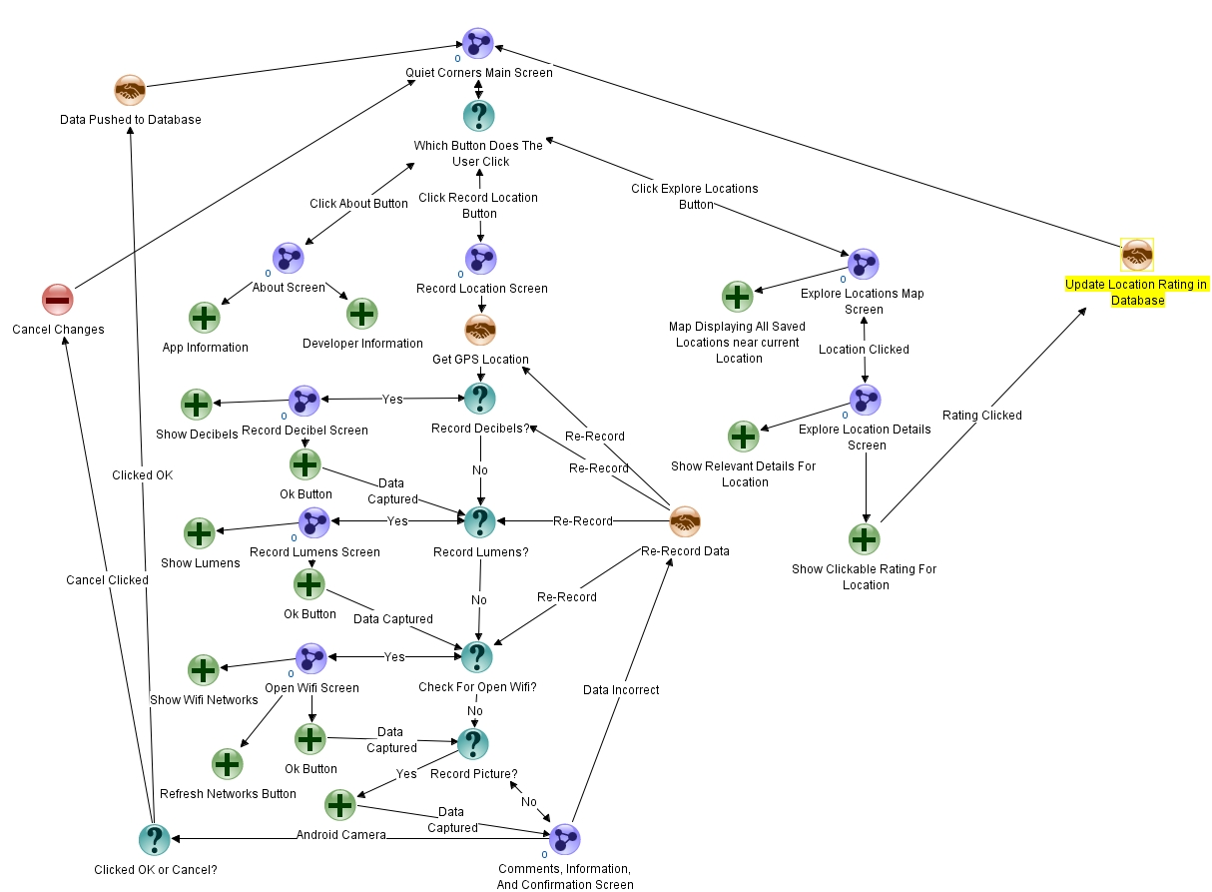C. Dialogue Map:

D. Screen Mockups:

# Main Screen:

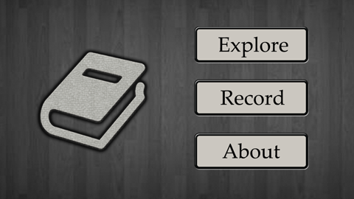

# About Screen:

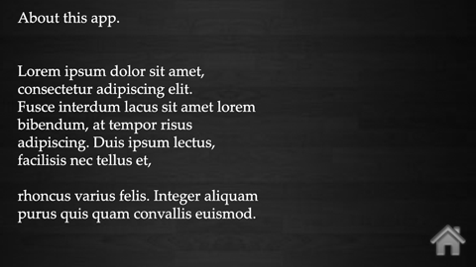

# Record Location Screen:

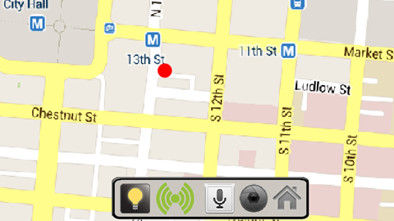

# Capture Decibel Screen:C:\Users\erik3_000\Downloads\Images\screenRecordDecibels.png

# Capture Lumen Screen:

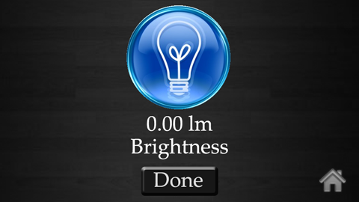

# Record Picture Screen:

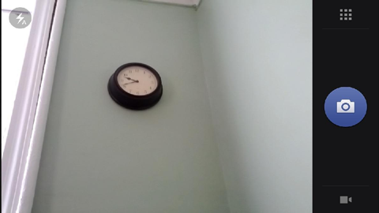

# Explore Screen:

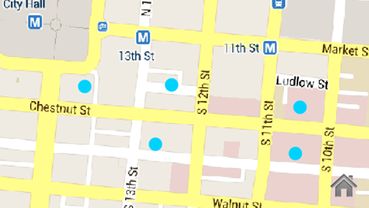

# Location Information Screen:

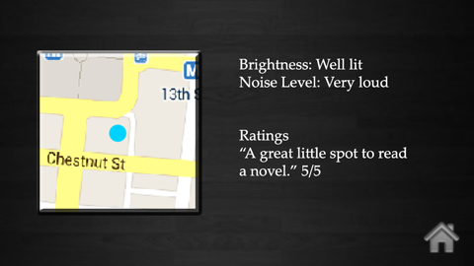

E. Features List:

Create New Corners: users will be able to create their own Quiet Corners submission that will be stored externally on a MySQL database. The submissions will have variables grading and describing the corner for other users to see when they view the submission.

GPS Location: each submission will contain a GPS location by default using built in GPS systems. This location will be saved with the submission on the external MySQL database and will be used when users search for nearby Quiet Corners.

Decibel Meter: each submission will have the submitter attach a rating of the ambient sound of the location. This reading will be taken using the internal recording devices of the phone and translated into a decibel measurement and sound rating. If the proper recording devices are not available on the phone, the submitter will be prompted to submit their own subjective rating. The sound rating information will be available when other users view the Quiet Corner through the external MySQL database.

Lumen Meter: each submission will have the submitter attach a rating of the ambient light of the location. This reading will be taken using the internal light sensors of the phone and translated into a lumen measurement and lighting rating. If the proper light sensors are not available on the phone, the submitter will be prompted to submit their own subjective rating. The lighting rating information will be available when other users view the Quiet Corner through the external MySQL database.

Wifi Information: each submission will have the submitter attach a rating of the wireless signal available at the location. This reading will be taken using the built in wireless tracking system on the phone and translated into a rating of signal strength. It will also be recorded if the wireless signal is password protected or not. The wireless signal information will be available when other users view the Quiet Corner through the external MySQL database.

Picture of Corner: each submission will have the submitter attach a picture of the location. The picture will be taken using the internal camera built into the phone. If the camera is unavailable, the picture will appear blacked out. The picture of the location will be available when other users view the Quiet Corner through the external MySQL database.

Corner Comments and Additional Information: each submission prompt the submitter to give any relevant additional information in text form. The comments/information can refer to an overall rating from the submitter or perhaps information like wireless passwords. The submitter will enter the comments/information using the internal keyboard input of the phone. The additional information text will be available when other users view the Quiet Corner through the external MySQL database.

Rating: all submissions will have overall ratings averaged from all users who use the location. This rating will be given using a button interface in the application, rating between one and five stars. The initial submitter will be the first to rate the location and then other users can rate the location. The rating of the location will be available to view and submit when users view the Quiet Corner through the external MySQL database.

Quiet Corner Locator: users can search for other user’s submissions using the corner locator. The locator will use internal GPS sensors to view the user’s current location and then compare it to the submission locations stored in the MySQL database. Nearby locations will then be displayed using the built in GPS and mapping features of the phone. Pressing on a location will allow the user to view all of a submission’s information (location, decibel rating, wireless information, etc.) that is stored on the external MySQL database.

F. Conclusion:

Much time and effort has been put into gauging the interest in such an app, and the general consensus is one of excitement. We hope you take are proposal into consideration, and thank you for time.

G. References:

# Locations Searched:

## Apple App Store: https://itunes.apple.com

## Google Play Store: https://play.google.com

## Google: https://google.com